Week 2 - DAY-2 Hands-On Activities Keerthivasan R

PROBLEM 1: Student Marks Analyzer (LEVEL-1)
Scenario:
You are developing a small utility for a teacher to analyze student marks stored in an array.

📌 Requirements
- Store student marks in an array.
- Calculate total and average marks using array methods.
- Display pass/fail result based on average.
- Use let/const appropriately.
- Use arrow functions for calculations.
- Display output using template literals.

🛠️ Technical Constraints
- Must use array methods like reduce() and map().
- Use only ES6+ syntax.
- No external libraries.
- All logic must be inside modular JavaScript file.

🎯 Learning Outcome
- Understand array processing.
- Practice ES6 features.
- Learn modular coding structure.
CODE:
<!DOCTYPE html>
<html>

<head>
<title>Student Marks Analyzer</title>
<style>
body {
font-family: Arial;
background-color: #f4f4f4;
padding: 30px;
}

h2 {
margin-bottom: 20px;
}

button {
padding: 6px 12px;
cursor: pointer;
}

pre {
background: white;
padding: 15px;
width: 60%;
border: 1px solid #999;
}
</style>
</head>

<body>

<h2>Student Marks Analyzer</h2>

<button onclick="analyzeMarks()">Analyze Marks</button>

<pre id="output"></pre>

<script>
// Array storing student marks
const marks = [78, 85, 90, 67, 88];

/*
Arrow function to calculate total marks
reduce() loops through array and accumulates sum
sum → accumulator
mark → current value
0 → initial value
*/
const calculateTotal = arr =>
arr.reduce((sum, mark) => sum + mark, 0);

// Calculates average using total / length
const calculateAverage = arr =>
calculateTotal(arr) / arr.length;

// Ternary operator to determine pass/fail
const getResult = avg =>
avg >= 50 ? "Pass" : "Fail";

// Main function triggered by button click
const analyzeMarks = () => {

const total = calculateTotal(marks);
const average = calculateAverage(marks);
const result = getResult(average);

// Display output using template literals
document.getElementById("output").textContent = `
Marks: ${marks.join(", ")}
Total: ${total}
Average: ${average.toFixed(2)}
Result: ${result}
`;
};
</script>

</body>

</html>

OUTPUT:
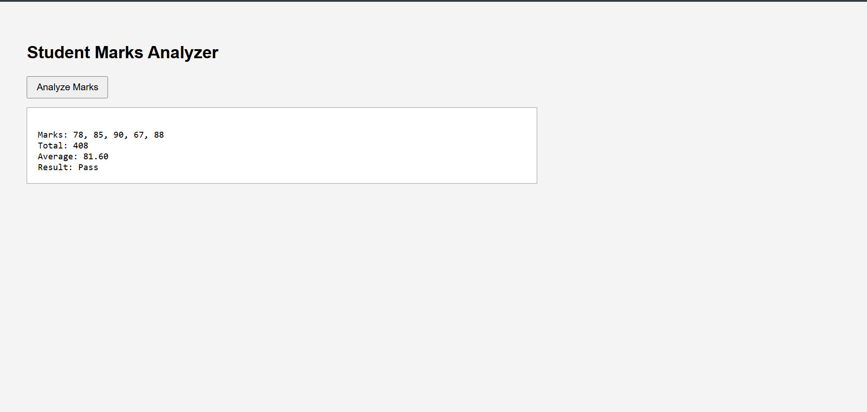
PROBLEM 2: Product Cart Summary (LEVEL-1)
Scenario:
Build a simple shopping cart summary system.

📌 Requirements
- Store product objects (name, price, quantity) in an array.
- Calculate total cart value.
- Display formatted invoice using template literals.
- Use arrow functions.
- Export calculation function from a module.

🛠️ Technical Constraints
- Use map() and reduce().
- Use ES6 modules (export/import).
- No DOM manipulation required.

🎯 Learning Outcome
- Work with arrays of objects.
- Understand modules.
- Improve functional programming skills.
CODE:
<!DOCTYPE html>
<html>

<head>
<title>Product Cart Summary</title>
<style>
body {
font-family: Arial;
background-color: #f4f4f4;
padding: 30px;
}

h2 {
margin-bottom: 20px;
}

button {
padding: 6px 12px;
cursor: pointer;
}

pre {
background: white;
padding: 15px;
width: 60%;
border: 1px solid #999;
}
</style>
</head>

<body>

<h2>Shopping Cart Summary</h2>

<button onclick="generateInvoice()">Generate Invoice</button>

<pre id="invoice"></pre>

<script>
// Array of product objects
const products = [
{ name: "Laptop", price: 50000, quantity: 1 },
{ name: "Mouse", price: 500, quantity: 2 },
{ name: "Keyboard", price: 1500, quantity: 1 }
];

/*
Calculate total cart value
price * quantity for each product
*/
const calculateCartTotal = items =>
items.reduce((total, item) =>
total + item.price * item.quantity, 0);

const generateInvoice = () => {

const total = calculateCartTotal(products);

// map() creates formatted product list
document.getElementById("invoice").textContent = `
${products.map(p =>
`${p.name} - ₹${p.price} x ${p.quantity}`
).join("\n")}

Total Amount: ₹${total}
`;
};
</script>

</body>

</html>
OUTPUT:
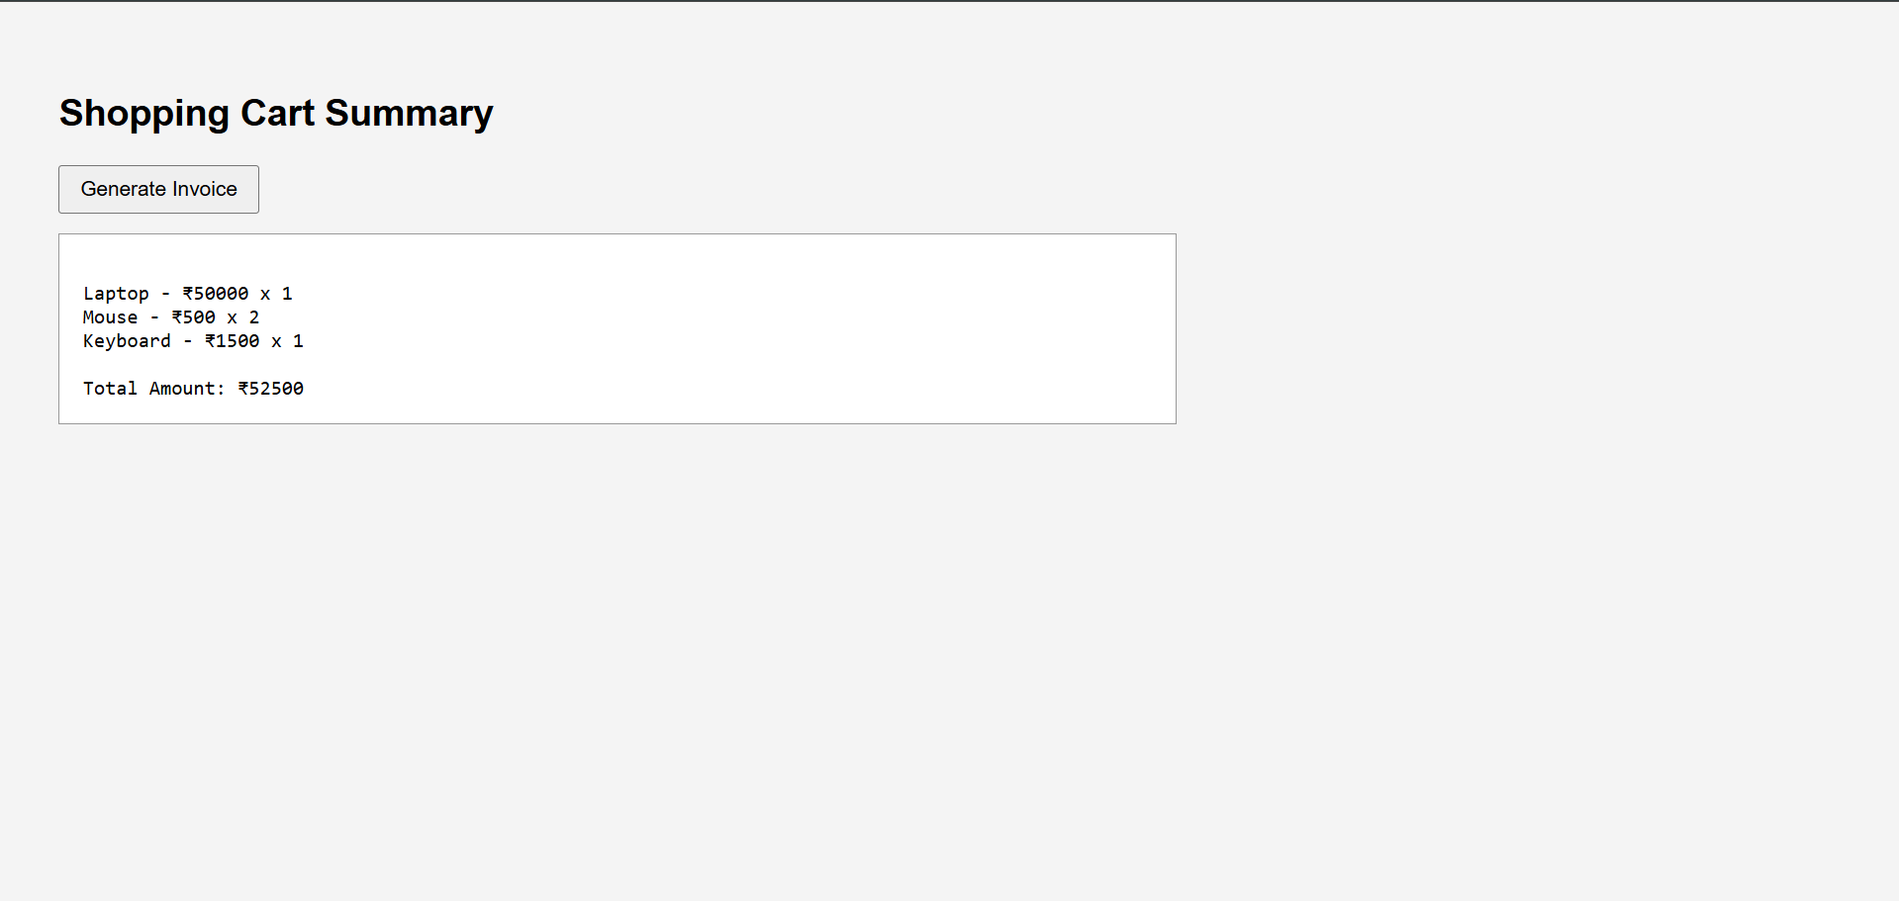
PROBLEM 3: Weather Data Fetcher (LEVEL-2)

Scenario:
Create an application that fetches weather data asynchronously.

📌 Requirements
- Fetch data from a public API using fetch().
- Implement version using Promises.
- Implement version using async/await.
- Handle errors properly.
- Display formatted weather report.

🛠️ Technical Constraints
- Use async/await.
- Use template literals.
- Use arrow functions.
- Must include proper error handling using try/catch.

🎯 Learning Outcome
- Understand Promises and async/await.
- Handle asynchronous operations.
- Improve API handling skills.
CODE:
<!DOCTYPE html>
<html>

<head>
<title>Weather Data Fetcher</title>
<style>
body {
font-family: Arial;
background-color: #f4f4f4;
padding: 30px;
}

h2 {
margin-bottom: 20px;
}

button {
padding: 6px 12px;
cursor: pointer;
}

pre {
background: white;
padding: 15px;
width: 60%;
border: 1px solid #999;
}
</style>
</head>

<body>

<h2>Weather Data Fetcher</h2>

<button onclick="fetchWeather()">Get Weather</button>

<pre id="weatherOutput"></pre>

<script>
// API endpoint (Hyderabad location)
const API_URL =
"https://api.open-meteo.com/v1/forecast?latitude=17.3850&longitude=78.4867&current_weather=true";

/*
Async function allows use of await
await pauses execution until Promise resolves
*/
const fetchWeather = async () => {
try {

// Fetch data from API
const response = await fetch(API_URL);

// Check if response is successful
if (!response.ok) {
throw new Error("Failed to fetch data");
}

// Convert response to JSON
const data = await response.json();

// Display weather details
document.getElementById("weatherOutput").textContent = `
Temperature: ${data.current_weather.temperature}°C
Wind Speed: ${data.current_weather.windspeed} km/h
`;

} catch (error) {
// Handle errors
document.getElementById("weatherOutput").textContent =
"Error: " + error.message;
}
};
</script>

</body>

</html>

OUTPUT:
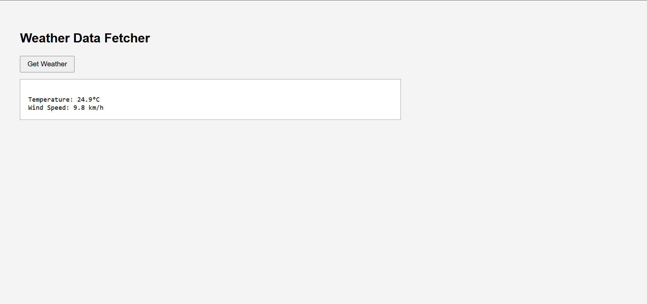

PROBLEM 4: Task Manager with Async Storage (LEVEL-2)

Scenario:
Develop a task manager where tasks are saved and retrieved asynchronously.

📌 Requirements
- Store tasks in an array.
- Create addTask(), deleteTask(), and listTasks() functions.
- Simulate async storage using setTimeout with callbacks.
- Convert callback-based logic into Promises.
- Refactor into async/await version.
- Use ES6 modules.

🛠️ Technical Constraints
- Must demonstrate callback → promise → async/await evolution.
- Use let/const properly.
- Use arrow functions.
- Use template literals for display.

🎯 Learning Outcome
- Deep understanding of async JavaScript.
- Learn refactoring async code.
- Master modern ES6+ features.
CODE:
<!DOCTYPE html>
<html>

<head>
<title>Task Manager</title>
<style>
body {
font-family: Arial;
background-color: #f4f4f4;
padding: 30px;
}

h2 {
margin-bottom: 20px;
}

input {
padding: 6px;
margin-right: 10px;
}

button {
padding: 6px 12px;
cursor: pointer;
margin-right: 5px;
}

table {
margin-top: 20px;
border-collapse: collapse;
width: 60%;
background: white;
}

th,
td {
border: 1px solid #999;
padding: 10px;
text-align: center;
}

th {
background-color: #ddd;
}
</style>
</head>

<body>

<h2>Task Manager (Async Storage)</h2>

<input type="text" id="taskInput" placeholder="Enter task">
<button onclick="addTask()">Add Task</button>
<button onclick="listTasks()">List Tasks</button>

<h3>Task List</h3>

<table id="taskTable">
<thead>
<tr>
<th>No</th>
<th>Task</th>
<th>Action</th>
</tr>
</thead>
<tbody></tbody>
</table>

<script>

// Array to store tasks in memory
let tasks = [];

/*
Add task (simulated async using setTimeout)
Mimics database delay
*/
const addTask = () => {

const task = document.getElementById("taskInput").value;

if (!task) {
alert("Please enter a task");
return;
}

setTimeout(() => {
tasks.push(task); // Add task to array
alert("Task is added successfully!");
document.getElementById("taskInput").value = "";
}, 500);
};

/*
Delete task using index
splice() removes element from array
*/
const deleteTask = (index) => {

setTimeout(() => {
tasks.splice(index, 1);
alert("Task deleted successfully!");
listTasks(); // Refresh UI
}, 500);
};

/*
Display tasks in table
*/
const listTasks = () => {

const tbody = document.querySelector("#taskTable tbody");
tbody.innerHTML = "";

// If no tasks available
if (tasks.length === 0) {
tbody.innerHTML = `
<tr>
<td colspan="3">No tasks available</td>
</tr>
`;
return;
}

// Loop through tasks using forEach
tasks.forEach((task, index) => {

tbody.innerHTML += `
<tr>
<td>${index + 1}</td>
<td>${task}</td>
<td>
<button onclick="deleteTask(${index})">
Delete
</button>
</td>
</tr>
`;
});
};

</script>

</body>

</html>
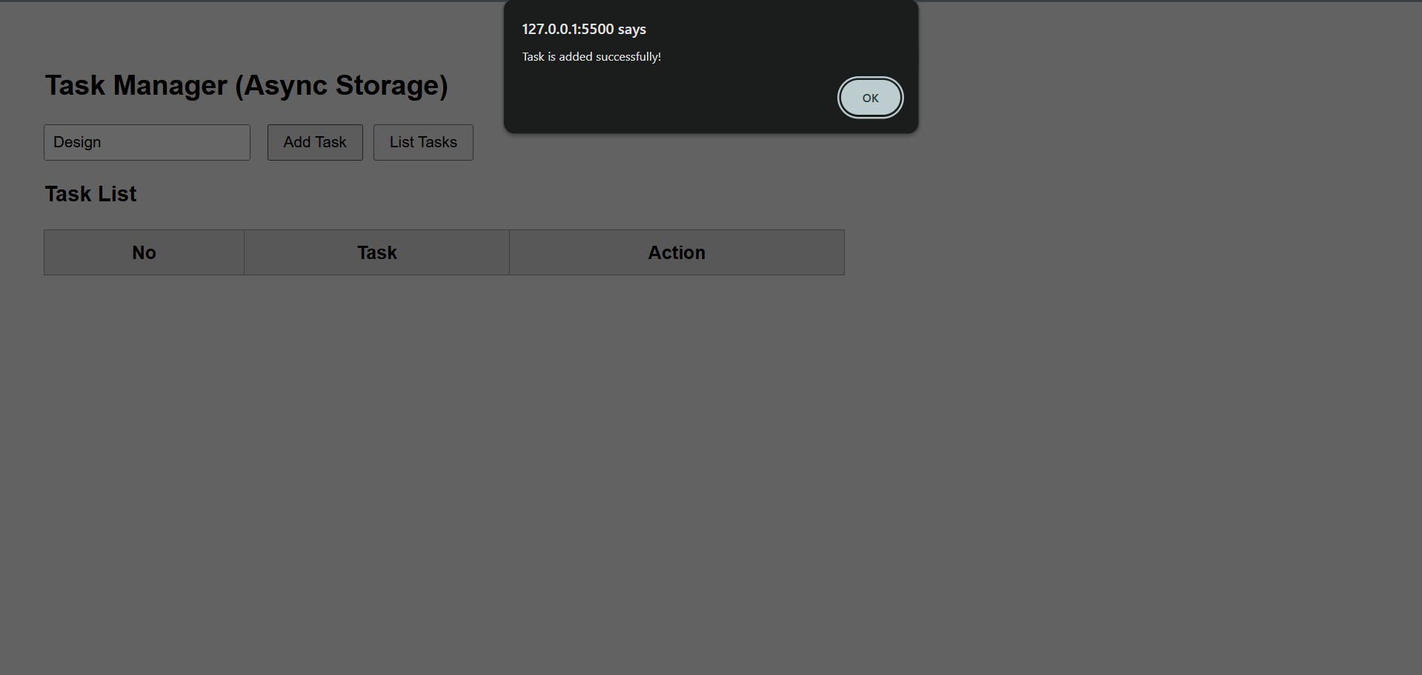
OUTPUT:

